**Week – 2 JUnit Testing Exercises**

**Exercise 1: Setting Up Junit**

**Code :**

**src/Calculator.java**

public class Calculator {

public int add(int a, int b) {

return a + b;

}

public int subtract(int a, int b) {

return a - b;

}

}

**src/CalculatorTest.java**

import org.junit.Test;

import static org.junit.Assert.*;

public class CalculatorTest {

@Test

public void testAdd() {

Calculator c = new Calculator();

assertEquals(5, c.add(2, 3));

}

@Test

public void testSubtract() {

Calculator c = new Calculator();

assertEquals(4, c.subtract(7, 3));

}

}

**Output :**

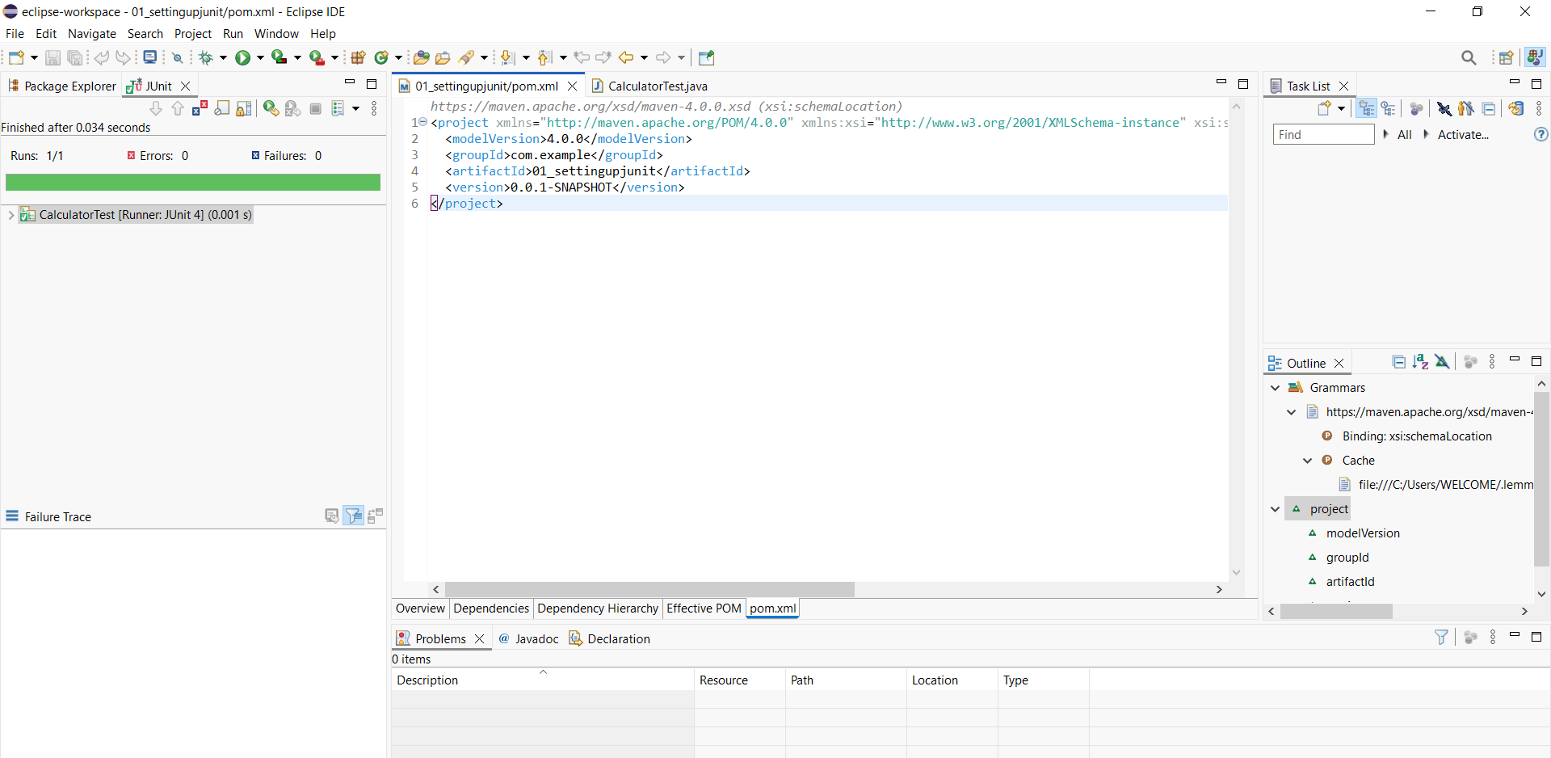

**Exercise 3: Assertions in Junit**

**Code :**

import org.junit.Test;

import static org.junit.Assert.*;

public class AssertionsTest {

@Test

public void testAssertions() {

assertEquals(5, 2 + 3);

assertTrue(5 > 3);

assertFalse(5 < 3);

assertNull(null);

assertNotNull(new Object());

}

}

**Output :**

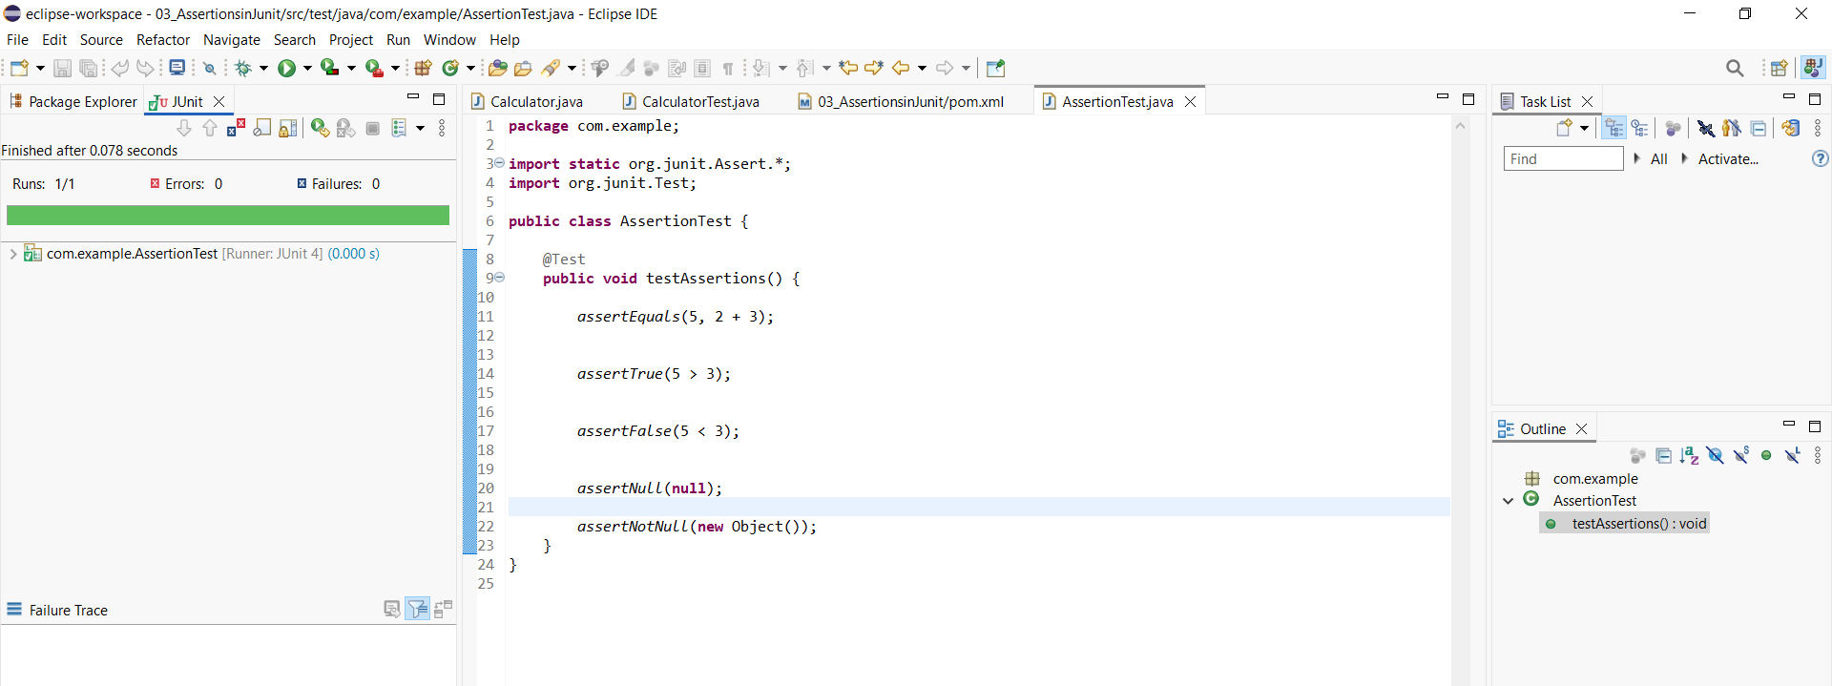

**Exercise 4: Arrange-Act-Assert (AAA) Pattern, Test Fixtures, Setup and Teardown Methods in Junit**

**Code :**

import org.junit.Before;

import org.junit.After;

import org.junit.Test;

import static org.junit.Assert.*;

public class CalculatorTest {

private Calculator calc;

@Before

public void setUp() {

System.out.println("Setting up Calculator...");

calc = new Calculator();

}

@After

public void tearDown() {

System.out.println("Cleaning up Calculator...");

calc = null;

}

@Test

public void testAddition() {

int a = 2;

int b = 3;

int result = calc.add(a, b);

assertEquals(5, result);

}

@Test

public void testSubtraction() {

int a = 10;

int b = 4;

int result = calc.subtract(a, b);

assertEquals(6, result);

}

}

**Calculator.java :**

public class Calculator {

public int add(int a, int b) {

return a + b;

}

public int subtract(int a, int b) {

return a - b;

}

}

**Output :**

